ITEM DETAILS
Name of Item | Inter-War Flats
Other Name/s  Former Name/s | 7-9 Wonderland Avenue, Tamarama
Item type | Built
Item group | Flat Building
Item category | Flat
Area, Group, or Collection Name | Unknown
Street number | 7-9
Street name | Wonderland Avenue
Suburb/town | Tamarama |  |  |  |  | Postcode |  |  | 2026
Local Government Area/s | Waverley
Property description | Lot B DP 329513
Location - Lat/long | Latitude | -33.897267 |  | Longitude | 151.268777
Location - AMG (if no street address) | Zone |  |  | Easting |  |  |  | Northing
Owner | Private
Current use | Residential
Former Use | Residential
Statement of significance | 7-9 Wonderland Avenue is a notable, fine and intact example of a pair of three-storey freestanding Inter-War Spanish Mission flat buildings that are outstanding in their precinct. It demonstrates the Wonderland City subdivision, 1919.  7-9 Wonderland Avenue represents the development of Inter-War flat buildings, an important phase in the history of Waverley which represents the 1920s-1930s development boom, a prominent period of economic prosperity and speculative development in Waverley associated with the changing demographics with a shift to living in flats.  The building is a notable example of the development of flat building in Tamarama, associated with 1934 Spanish Mission preference, and demonstrates the change in patterns in the late Inter-War period to incorporate garages, which reflect the growth of private vehicle ownership.  It is one of few pairs of Inter-War Spanish Mission style flats in Waverley.
Level of Significance | National |  | State |  |  |  | Local

DESCRIPTION
Designer

Builder/ maker | Albert Farley
Physical Description | 7-9 Wonderland Avenue, Tamarama is a pair of three-storey freestanding flat building that are part of a group that dates from the Inter-War period (1933-1934), the key period of significance of the Wonderland City subdivision.  The building displays features of the Inter-War Spanish Mission style including stucco with exaggerated texture, decorative parapet, grouped arched openings, arcaded loggias, ornamental metalwork, barley twist columns and cartouches. The building is setback 8 metres from the street on irregular elevated sites approximately 12 metres wide, that reflects the 1919 subdivision pattern in their street presentation. The suburban setting has partially lost its historic context. The site is unfenced and has a driveway with wheel strips and crazy paving accessing basement garages which date from the 1934 period. The site also features a central right of way.  The site of No.9 is informally landscaped, and features steps and provides an appropriate setting for the building. The setting of No 7 is dominated by painted surfaces and car parking. The plan layout features 2 flats per floor with central entry (Type 1 – Waverley Inter-War Flats Guidelines). The buildings appear to be in good condition and are substantially intact.  No. 7 Wonderland Avenue had alterations approved in 2013.  Elements impacting upon the integrity of the site includes metalwork balconies removed, glass balconies added, fenestration, new stairs, rear balcony/pergola, loggia infilled, and new garage doors.
Physical condition  and  Archaeological potential | The building appears to be in good condition
Construction years | Start year | 1933 | Finish year | 1933 | Circa
Modifications and dates

HISTORY
Historical notes | 7-9 Wonderland Avenue, Tamarama was part of William Anderson’s purchase of land in 1906. The land was subdivided under DP 9842 by William Anderson. The Auction Sale of lots in the Wonderland City Subdivision was held on 15 November 1919. The sites of 7 and 9 Wonderland Avenue were Lots 10 and 11 in this subdivision. John Gordon Bannerman purchased lots on north side of Wonderland Avenue in 1920. The lots changed hands many times through the 1920s. In December 1933, Maud Farley purchased Lot 11, and in March 1934, she purchased the adjoining Lot 10. Farley was the wife of Albert Farley, a builder of Woollahra. Two Building Applications for six residential flats for Mr and Mrs A. Farley were submitted to Council in 1933 and 1934. The plans for both Building Applications note Lot 12, but the dimensions indicate Lot 11.

THEMES
National  historical theme | 4 Building settlements, towns and cities  8 Developing Australia’s Cultural Life
State  historical theme | Land tenure  Accommodation  Domestic life  Creative endeavour
Local  historical theme | Flats and Bungalows  Speculation and Subdivision

Assessment
A: Historical Significance | The site, 7-9 Wonderland Avenue, Tamarama has historical significance at a local level as it demonstrates the Wonderland City subdivision, 1919.  7-9 Wonderland Avenue, Tamarama has historical significance at a local level as it represents the development of Inter-War flat buildings, an important phase in the history of Waverley which represents the 1920s-1930s development boom, a prominent period of economic prosperity and speculative development in Waverley associated with the changing demographics with a shift to living in flats.  The building is a notable example of the development of flat building in Tamarama, associated with 1934 Spanish Mission preference, and demonstrates the change in patterns in the late Inter-War period to incorporate garages, which reflect the growth of private vehicle ownership.
B: Associative | To date research indicates that no historic association significance has been identified.
C: Aesthetic significance | 7-9 Wonderland Avenue has aesthetic significance at a local level as it is a notable, fine, and intact example of a pair of three-storey freestanding Inter-War Spanish Mission flat buildings that are outstanding in their precinct. The buildings show an accomplished use of Inter-War Spanish Mission styles which features stucco with exaggerated texture, decorative parapet, grouped arched openings, arcaded loggias, ornamental metal work, barley twist columns and cartouches.
D: Social significance | To date research indicates that no social, cultural, and spiritual significance has been identified.
e) Technical/  Research significance | To date research indicates that no research/technical significance has been identified.
f) Rarity | 7-9 Wonderland Avenue has rarity significance at a local level as it is one of few pairs of Inter-War Spanish Mission style flats in Waverley.
g) Representative-ness | 7-9 Wonderland Avenue has representative significance at a local level as fine examples of Inter-War Spanish Mission flat buildings in Waverley.
Integrity | The building is substantially intact.
Recommended Management | Slot garage

HERITAGE LISTINGS
Heritage listing/s | Draft Waverley LEP 2012

INFORMATION SOURCES
Type | Author/Client | Title | Year | Repository
 | Waverley Council | Waverley Heritage Policy | 2007
 | Waverley Council | Waverley Heritage Study | 1993
 | Perumal Murphy Pty Ltd | Waverley Heritage Study | 1990
 |  | Certificate of Title Vol 1826 Fol 3 |  | NSW Land Registry Services.
 |  | Certificate of Title Vol 3125 Fol 236 |  | NSW Land Registry Services.
 |  | Certificate of Title Vol 3497 Fol 158 |  | NSW Land Registry Services.
Building Plan |  | B33/280, B34/22 |  | Waverley Council

RECOMMENDATIONS
Recommendations

SOURCE OF THIS INFORMATION
Name of study or report | Heritage Policy by Waverley Council reviewed by Architectural Projects 2023 |  | Year of study or report
Item number in study or report
Author of study or report
Inspected
NSW Heritage Manual guidelines used? |  |  |  | Yes |  | No
This form completed by |  |  |  | Date

IMAGES

Image caption | 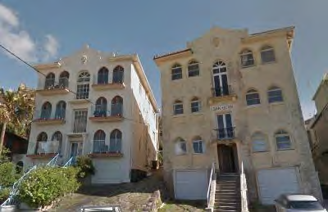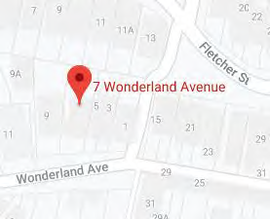
Image year |  | Image by | Google Maps | Image copyright holder

Image caption | 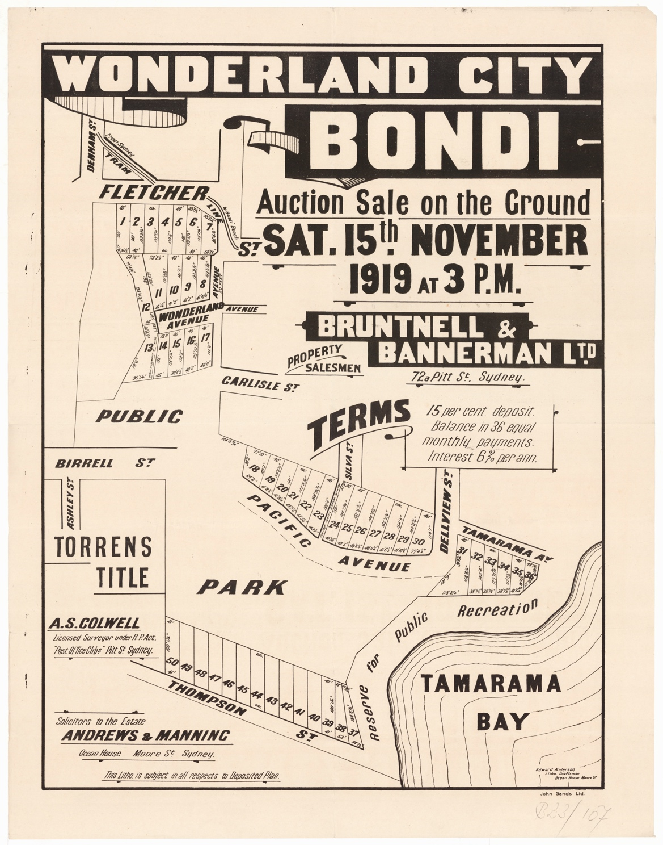
Image year | 1919 | Image by | State Library of New South Wales | Image copyright holder

Image caption | 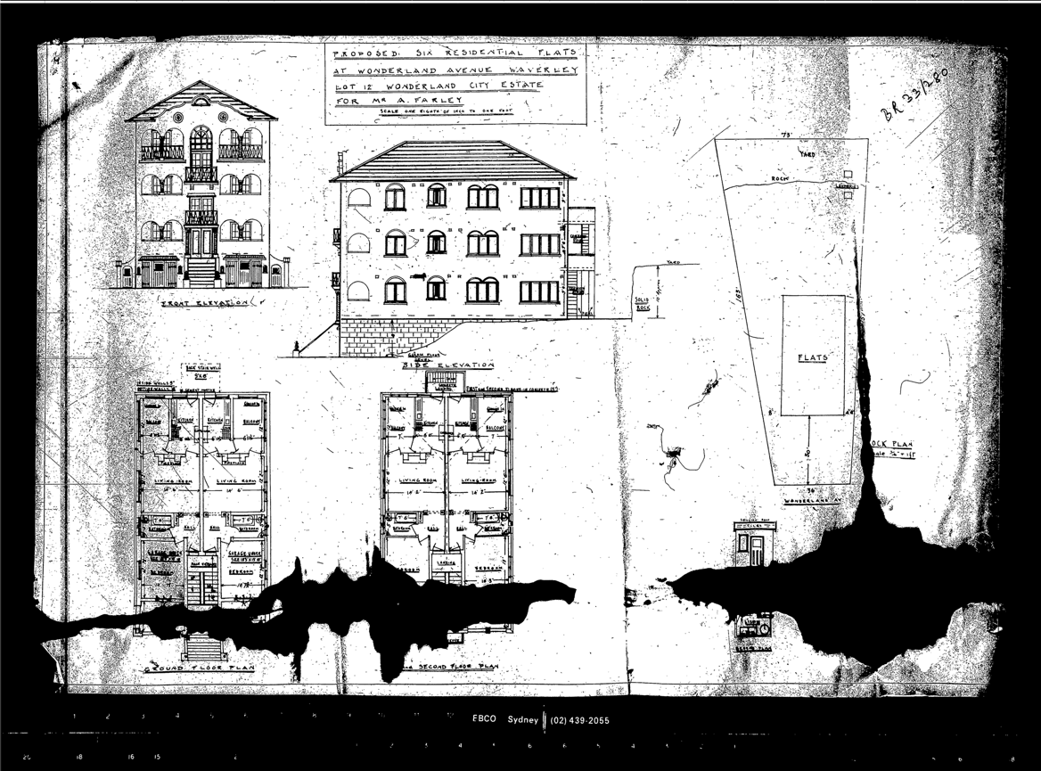
Image year | 1933 | Image by | Waverley Council | Image copyright holder

Image caption | 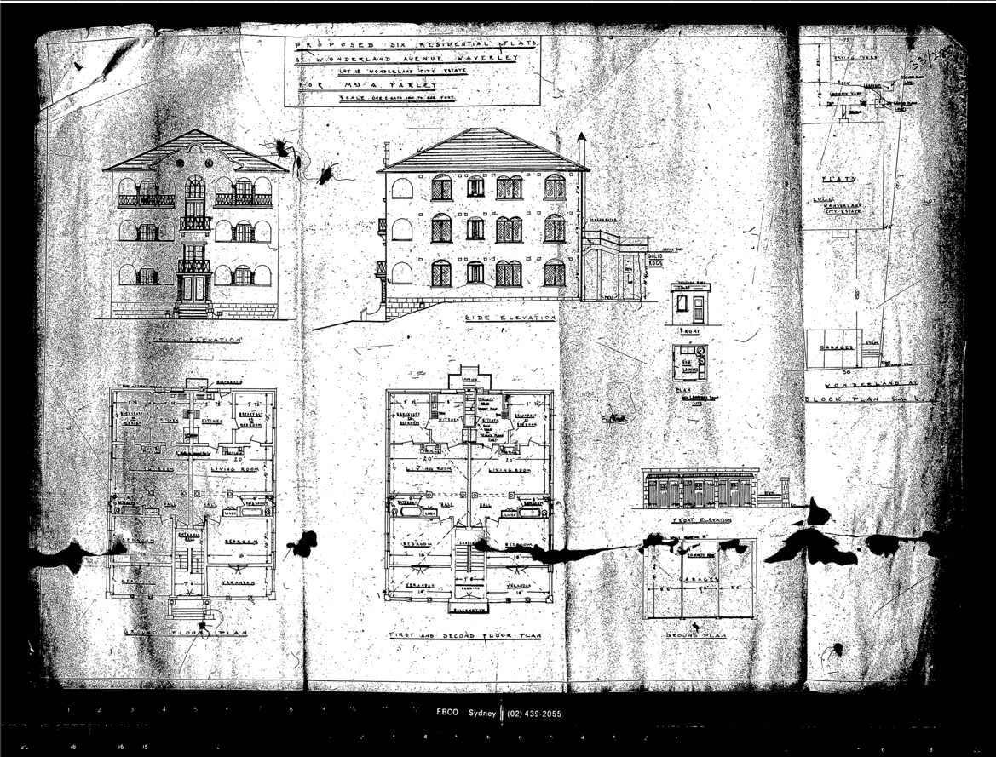
Image year | 1933 | Image by | Waverley Council | Image copyright holder

Image caption | 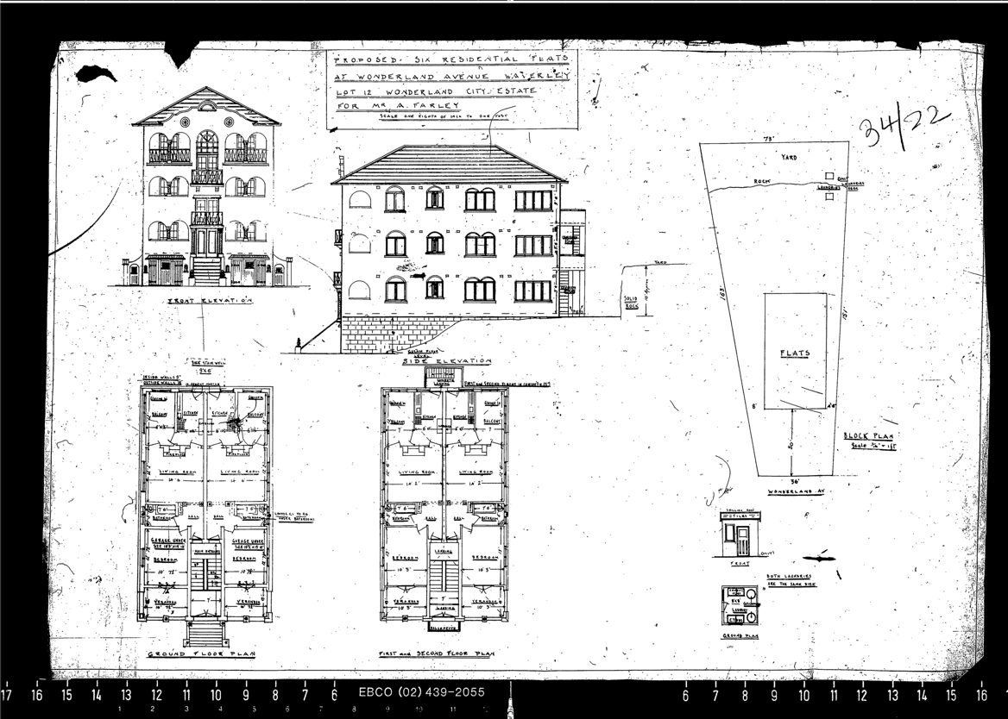
Image year | 1934 | Image by | Waverley Council | Image copyright holder

